A
Internship Report on

Comparative Analysis of four Machine Learning Models for Software Bug Prediction
Using the JM1 Dataset
Submitted in partial fulfillment of the requirements for the award of Degree of
BACHELOR OF ENGINEERING
In
COMPUTER SCIENCE AND ENGINEERING

By
Haniya Shaik (160622733116)

Under the Guidance of

Mrs. Shaheda Begum
Assistant Professor
Department of Computer Science and Engineering

DEPARTMENT OF COMPUTER SCIENCE AND ENGINEERING STANLEY COLLEGE OF ENGINEERING & TECHNOLOGY FOR WOMEN (AUTONOMOUS)
(Affiliated to Osmania University, Approved by AICTE and Accredited by NAAC)
Hyderabad - 500 001, Telangana, India
STANLEY COLLEGE OF ENGINEERING & TECHNOLOGY FOR WOMEN
(AUTONOMOUS)
(Affiliated to Osmania University, Approved by AICTE and Accredited by NAAC)
Hyderabad - 500 001, Telangana, India
DEPARTMENT OF COMPUTER SCIENCE AND ENGINEERING


CERTIFICATE

This is to certify that the Internship report entitled, “Comparative Analysis of four Machine Learning Models for Software Bug Prediction”, done by Haniya Shaik (160622733116), Submitting to the Department of Computer Science and Engineering, STANLEY COLLEGE OF ENGINEERING & TECHNOLOGY FOR WOMEN, in partial fulfillment of the requirements for the Degree of BACHELOR OF ENGINEERING in Computer Science and Engineering, at Defence Research And Development Laboratory (DRDL) during the year 2024-25. It is certified that she has completed the project satisfactorily.


Signature of Supervisor / Faculty Coordinator Mrs. Shaheda Begum
Assistant Professor
Signature of Head of the Department Dr. R. Madana Mohana
Professor & Head
STANLEY COLLEGE OF ENGINEERING & TECHNOLOGY FOR WOMEN
(AUTONOMOUS)
(Affiliated to Osmania University, Approved by AICTE and Accredited by NAAC)
Hyderabad - 500 001, Telangana, India
DEPARTMENT OF COMPUTER SCIENCE AND ENGINEERING

DECLARATION

I hereby declare that the work described in this report entitled “Comparative Analysis of Four Machine Learning Models for Software Bug Prediction Using the JM1 Dataset” which is being submitted by us in partial fulfillment for the award of BACHELOR OF ENGINEERING in the Department of Computer Science and Engineering, Stanley College of Engineering & Technology for Women to the Osmania University Hyderabad.

The work is original and has not been submitted for any Degree or Diploma of this or any other university.

Signature of the Student Haniya Shaik 160622733116
STANLEY COLLEGE OF ENGINEERING & TECHNOLOGY FOR WOMEN
(AUTONOMOUS)
(Affiliated to Osmania University, Approved by AICTE and Accredited by NAAC)
Hyderabad - 500 001, Telangana, India
DEPARTMENT OF COMPUTER SCIENCE AND ENGINEERING


INTERNSHIP - II DETAILS
Course Code: SPW611 CS Credits: 1 Evaluation: CIE - 50 Marks

Title: Comparative Analysis of Four Machine Learning Models for Software Bug Prediction Using the JM1 Dataset
Name of the Student: Haniya Shaik Roll Number: 160622733116
Batch / Section: 2025 – 2026 / B
Name of the Organization: Defiance Research and Development Laboratory (DRDL)
Duration of Internship: From 06th May 2025 to 05th June 2025
Mode (Onsite / Online / Hybrid): Onsite
Industry Supervisor: K. Rajasekharam Scientist ‘H’
Faculty Coordinator / Supervisor: Mrs. Shaheda Begum

Organization Profile

Overview of the Organization
The Defence Research and Development Laboratory (DRDL), a premier establishment under the Defence Research and Development Organisation (DRDO) located in Kanchanbagh, Hyderabad, was established in 1961 and is dedicated to the design, development, and production of missile systems and strategic defence technologies for the Indian Armed Forces. It plays a vital role in strengthening the nation’s defence capabilities through continuous innovation, advanced research, and technological excellence. Specializing in the development of tactical and strategic missile systems, propulsion technologies, and related subsystems, DRDL has been instrumental in the success of several indigenous missile programs, significantly contributing to India’s self-reliance in defence technology. The laboratory fosters a collaborative environment that combines scientific research, system engineering, and real-world defence applications, providing valuable learning exposure to researchers and interns. Through its cutting-edge research in areas such as aerodynamics, control systems, propulsion, materials, guidance, and simulation, DRDL continues to enhance India’s technological edge and operates under DRDO’s vision of achieving technological superiority for national security and global recognition in defence science and technology.

Vision, Mission, and Key Areas of Operation
Vision:
To achieve self-reliance in missile systems and related technologies, thereby strengthening India’s defence capabilities through continuous innovation, research, and development.
Mission:
To design, develop, and deliver state-of-the-art missile systems and technologies for the Armed Forces of India, ensuring technological excellence, reliability, and performance. The laboratory aims to foster scientific innovation, collaborative research, and industry partnerships to contribute towards national security and technological advancement.
Key Areas of Operation:
- Research and development of missile systems and subsystems
- Design and testing of propulsion, control, and guidance technologies
- Collaboration with academic institutions and industry for applied research

Organizational Structure
The Defence Research and Development Laboratory (DRDL) follows a well-defined hierarchical and functional structure that ensures efficient coordination, innovation, and mission success. Operating under the Defence Research and Development Organisation (DRDO), which is part of the Ministry of Defence, Government of India, DRDL is headed by a Director, who oversees all strategic, administrative, and technical activities of the laboratory. Under the Director, several specialized technical divisions function collaboratively, including Aerodynamics and Design, Propulsion Systems, Control and Guidance, System Integration and Testing, Materials and Metallurgy, and Quality Assurance. Each division is led by a Project Director or Group Head, supported by teams of Scientists, Research Fellows, Engineers, and Technical Officers, who work together on various research and development projects. This structure promotes interdisciplinary collaboration, accountability, and innovation, ensuring that every subsystem—from propulsion to guidance—is developed with precision and excellence. Regular project reviews, simulations, and technical evaluations are conducted to maintain high standards of performance, reliability, and readiness in all mission-critical defence systems.

Technologies or Tools Used
During the internship at DRDL, exposure was gained to research-oriented and data-driven technologies used in defence and computational analysis, with a primary focus on applying Machine Learning (ML) and Data Analytics for Software Bug Prediction, supporting the lab’s initiatives in software reliability and quality assurance.

Software Tools:
- Python — Core language for implementing ML models and data analysis.
- NumPy & Pandas — For data preprocessing, cleaning and manipulation.
- Matplotlib & Seaborn — For visualizing model performance and results.
- Imblearn (SMOTE) — To handle class imbalance and improve model accuracy.
These tools collectively supported the data processing, model training, evaluation, and documentation components of the internship, ensuring that the final project outcomes were technically robust, analytically sound, and professionally presented.

Internship Offer Letter

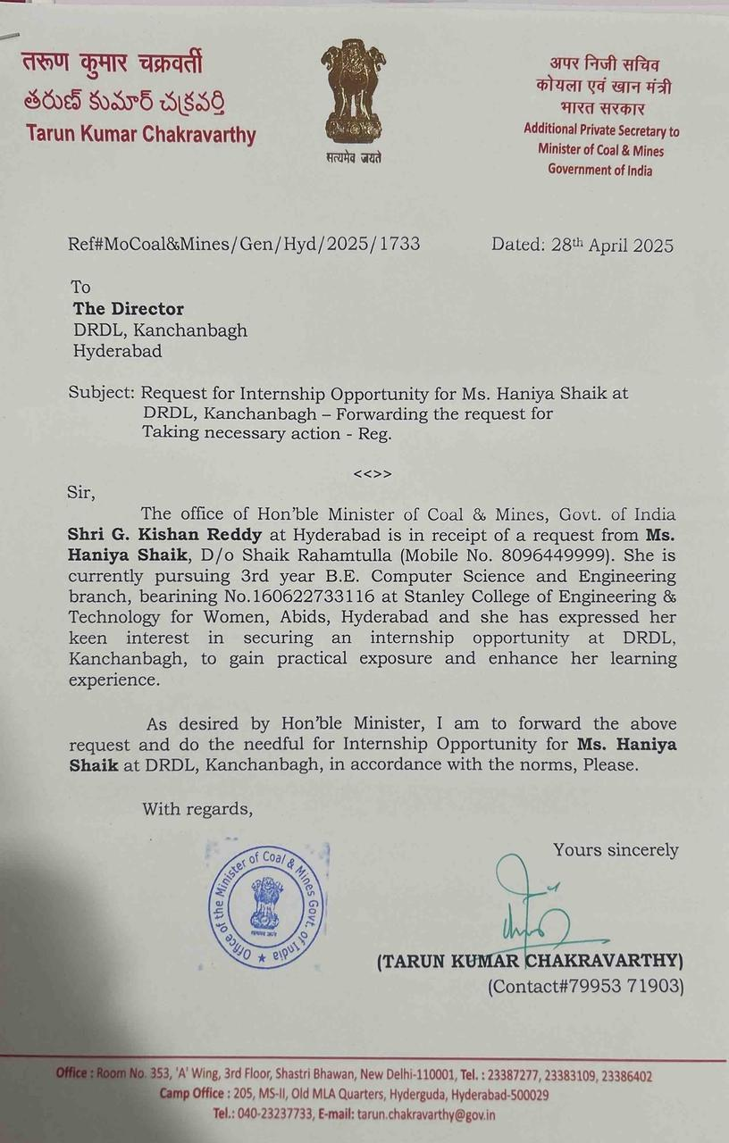

Internship Completion Certificate

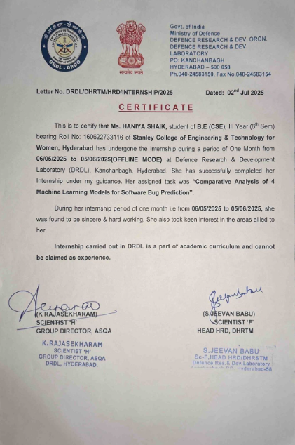

STANLEY COLLEGE OF ENGINEERING & TECHNOLOGY FOR WOMEN
(Autonomous)
Abids, Hyderabad - 500 001, Telangana

Department of Computer Science and Engineering

Vision of the Institute
Empowering girl students through professional education integrated with values and character to make an impact in the world.

Mission of the Institute
- Providing quality engineering education for girl students to make them competent and confident to succeed in professional practice and advanced learning.
- Establish state-of-art-facilities and resources to facilitate world class education.
- Integrating qualities like humanity, social values, ethics, leadership in order to encourage contribution to society.

Vision of the Department
Empowering girl students with the contemporary knowledge in computer science engineering for their success in life.

Mission of the Department
- To impart quality education for girl students to learn and practice various hardware and software platforms prevalent in industry.
- To achieve self-sustainability and overall development through Research and Development activities.
- To provide education for life by focusing on the inculcation of human & moral values through an honest and scientific approach.
- To groom students with good attitude, team work and personality skills.

Program Educational Objectives (PEOs)
PEO1. Graduates shall have enhanced skills and contemporary knowledge in software and hardware technologies for professional excellence, towards successful employment, advanced learning and research.
PEO2. Graduates shall have life-long learning attitude, innovation and creativity to master latest technologies, devise solutions for realistic and social issues in the society.
PEO3. Graduates shall have good attitude and personality skills, ethical values, teamwork and leadership skill towards professionalism and ethical practices within the organization and the society

STANLEY COLLEGE OF ENGINEERING & TECHNOLOGY FOR WOMEN
(Autonomous)
Abids, Hyderabad - 500 001, Telangana

Department of Computer Science and Engineering

Knowledge and Attitude Profile (WK)
WK1. | A systematic, theory-based understanding of the natural sciences applicable to the discipline and awareness of relevant social sciences.
WK2. | Conceptually-based mathematics, numerical analysis, data analysis, statistics and  formal aspects of computer and information science to support detailed analysis and modelling applicable to the discipline.
WK3. | A systematic, theory-based formulation of engineering fundamentals required in the engineering discipline.
WK4. | Engineering specialist knowledge that provides theoretical frameworks and bodies of knowledge for the accepted practice areas in the engineering discipline; much is at the forefront of the discipline.
WK5. | Knowledge, including efficient resource use, environmental impacts, whole-life cost, reuse of resources, net zero carbon, and similar concepts, that supports engineering  design and operations in a practice area.
WK6. | Knowledge of engineering practice (technology) in the practice areas in the engineering discipline.
WK7. | Knowledge of the role of engineering in society and identified issues in engineering practice in the discipline, such as the professional responsibility of an engineer to public safety and sustainable development.
WK8. | Engagement with selected knowledge in the current research literature of the discipline, awareness of the power of critical thinking and creative approaches to evaluate emerging issues.
WK9. | Ethics, inclusive behavior and conduct. Knowledge of professional ethics, responsibilities, and norms of engineering practice. Awareness of the need for diversity by reason of ethnicity, gender, age, physical ability etc. with mutual understanding and respect, and of inclusive attitudes.


STANLEY COLLEGE OF ENGINEERING & TECHNOLOGY FOR WOMEN
(Autonomous)
Abids, Hyderabad - 500 001, Telangana

Department of Computer Science and Engineering

Program Outcomes (POs)
PO1. | Engineering Knowledge: Applied core knowledge of mathematics, computer science, and machine learning algorithms to design and implement predictive models for software bug detection using real-world datasets at DRDL.
PO2. | Problem Analysis: Identified and analyzed the software defect prediction problem by reviewing research literature and evaluating various algorithms to reach data-driven conclusions for improved software reliability.
PO3. | Design/Development of Solutions: Developed and tested machine learning-based solutions (Logistic Regression, Decision Tree, Random Forest, and SVM) to design an effective bug prediction system that enhances software quality and performance.
PO4. | Conduct Investigations of Complex Problems: Conducted experiments with different models and datasets using Python, SMOTE, and evaluation metrics to derive valid conclusions on model accuracy and efficiency.
PO5. | Engineering Tool Usage: Utilized modern engineering and IT tools such as Python, scikit-learn, pandas, NumPy, and visualization libraries to preprocess data, train models, and analyze performance.
PO6. | The Engineer and The World: Understood the importance of reliable software systems in national defence applications, ensuring safety, accuracy, and sustainable development in technological advancements.
PO7. | Ethics: Maintained professional ethics, data confidentiality, and research integrity while working within the sensitive and secure environment of DRDL.
PO8. | Individual and Collaborative Team work: Collaborated with scientists and research mentors at DRDL while independently managing data preprocessing, model development, and documentation tasks.
PO9. | Communication: Prepared professional documentation, reports, and presentations to effectively communicate technical findings and model performance results to mentors and evaluators.
PO10. | Project Management and Finance: Applied systematic project planning, task prioritization, and resource management to complete the internship deliverables efficiently within the given duration.
PO11. | Life-Long Learning: Recognized the importance of continuous learning by exploring advanced machine learning concepts and adapting to emerging AI technologies used in defence research.
Program Specific Outcomes (PSOs)
PSO1. | Problem-Solving Skills: Demonstrated the ability to analyze software defect datasets and implement appropriate machine learning algorithms to develop a quality bug prediction model for DRDL applications.
PSO2. | Designed, implemented, tested, and compared multiple machine learning models (Logistic Regression, Decision Tree, Random Forest, SVM) to evaluate their performance and identify the most accurate predictive system for software defect detection.


STANLEY COLLEGE OF ENGINEERING & TECHNOLOGY FOR WOMEN
(Autonomous)
Abids, Hyderabad - 500 001, Telangana

Department of Computer Science and Engineering

Objectives and Outcomes of the Internship

Course Objectives:
- Provide hands-on experience in the design, development, and implementation of real-world software and information systems.
- Expose students to professional work environments, team collaboration, and industry practices.
- Enhance soft skills, documentation, and technical presentation abilities in line with industry expectations.
- Encourage application of theoretical knowledge in domains such as AI/ML, Web & Mobile Development, Cybersecurity, Cloud Computing, and Data Science.
- Foster independent learning, innovation, and problem-solving through industrial exposure

Course Outcomes:
After completing this course, the student will be able to:
- Gain practical experience in software development, coding standards, and tools used in industrial or R&D settings.
- Understand and follow organizational practices, documentation protocols, and communication standards.
- Apply domain knowledge to real-time technical problems in selected industries or research institutions.
- Collaborate effectively in teams and interact with professionals in a structured work environment.
- Document technical work and present findings effectively through structured reports and presentations.

STANLEY COLLEGE OF ENGINEERING & TECHNOLOGY FOR WOMEN
(Autonomous)
Abids, Hyderabad - 500 001, Telangana

Department of Computer Science and Engineering

Mapping of Course Outcomes with POs and PSOs

Course Outcomes (COs) | Program Outcomes (POs) |  |  |  |  |  |  |  |  |  |  | Program Specific Outcomes  (PSOs)
 | PO1 | PO2 | PO3 | PO4 | PO5 | PO6 | PO7 | PO8 | PO9 | PO10 | PO11 | PSO1 | PSO2
1. Gain practical experience in software development, coding standards, and tools used in industrial or R&D  settings. | 3 | 3 | 3 | 3 | 2 | _  _ | 1 | _ | 2 | 2 | _ | 3 | 3
2. Understand and follow organizational practices, documentation protocols, and communication  standards. | 2 | 2 | _ | _ | _ | 1 | 3 | 2 | 2 | 3 | _ | 2 | _
3. Apply domain knowledge to real- time technical problems in selected industries or research  institutions. | 3 | 3 | 3 | 3 | 2 | 2 | _ | _ | 3 | _ | _ | 3 | 2
4. Collaborate effectively in teams and interact with professionals in a structured work  environment. | _ | _ | _ | _ | _ | _ | 3 | 3 | 3 | 3 | 2 | _ | _
5. Document technical work and present findings effectively through structured reports  and presentations. | _ | 2 | _ | _ | 1 | _ | _ | 3 | 3 | 3 | 2 | 2 | _


STANLEY COLLEGE OF ENGINEERING & TECHNOLOGY FOR WOMEN
(Autonomous)
Abids, Hyderabad - 500 001, Telangana

Department of Computer Science and Engineering
Student Learning Outcomes

Skills Acquired:
During the internship at DRDL, significant skills were developed across technical, analytical, and professional areas. Technical skills included a solid understanding of Machine Learning algorithms, Data Preprocessing techniques, and Software Reliability Analysis. Analytical skills were enhanced through the evaluation and comparison of ML models, interpretation of results, and optimization for improved accuracy. The internship also strengthened problem-solving, teamwork, research writing, and time management abilities, while promoting effective communication and documentation practices essential for real-world technical environments.

Tools and Technologies Learned:
The internship provided both conceptual and practical exposure to various tools and technologies used in research and defence data analysis. Key technologies included Machine Learning (ML) for predictive modelling, Data Analytics for identifying software defects, and SMOTE for handling class imbalance. Tools such as Python, NumPy, pandas, scikit-learn, Matplotlib, Seaborn, and VS Code were actively used for model development, testing, and evaluation. Additionally, Microsoft Excel and Word were used for data recording and report documentation, ensuring structured and professional presentation of results.

Industry Exposure and Professional Ethics:
The internship at DRDL provided valuable exposure to defence research practices and a professional work environment, emphasizing discipline, confidentiality, and data integrity. Interactions with scientists and mentors promoted teamwork, accountability, and professionalism, while the experience strengthened research ethics, technical precision, and continuous learning essential for success in technology and defence research.

STANLEY COLLEGE OF ENGINEERING & TECHNOLOGY FOR WOMEN
(Autonomous)
Abids, Hyderabad - 500 001, Telangana

Department of Computer Science and Engineering

Mapping of Internship with SDGs
Roll No: 160622733116
Name: Haniya Shaik
Class, Semester & Section: 4, VII, B
Academic Year: 2025-2026
Title of Internship: Comparative Analysis of 4 Machine Learning Models for Software Bug Prediction
Domain: Artificial Intelligence and Machine Learning

Course Outcomes (COs) Mapping with SDGs:
SDG Mapping with Justification

Course Outcomes (COs) | Relevant SDGs | Justification of SDGs
CO1: Gain practical experience in software development, coding standards, and tools used in industrial or R&D settings. | SDG 4 – Quality Education  SDG 9 – Industry, Innovation and Infrastructure | The internship enhanced research- oriented technical learning and familiarization with advanced technologies like AI and Blockchain, promoting experiential learning (SDG 4) and contributing to innovation-driven industrial  frameworks (SDG 9).
CO2: Understand and follow organizational practices, documentation protocols, and communication standards. | SDG 8 – Decent Work and Economic Growth  SDG 16 – Peace, Justice and Strong Institutions | Adhering to professional documentation, ethical research conduct, and institutional communication guidelines reflects responsible academic work culture (SDG 8) and strengthens academic  integrity and transparency (SDG 16).
CO3: Apply domain knowledge to real-time technical problems in  selected industries or research institutions. | SDG 9 – Industry, Innovation and Infrastructure  SDG 11 – Sustainable Cities and Communities | The AI–Fuzzy Logic framework supports intelligent transportation, improving urban mobility (SDG 11),  while Blockchain promotes resilient healthcare infrastructure (SDG 9).
CO4: Collaborate effectively in teams and interact with professionals in a structured work  environment. | SDG 5 – Gender Equality  SDG 17 – Partnerships for the Goals | Active collaboration with mentors and researchers fostered inclusivity (SDG 5) and knowledge-sharing partnerships in a global academic context (SDG 17).
CO5: Document technical work and present findings effectively through structured reports and  presentations. | SDG 4 – Quality Education  SDG 12 – Responsible Consumption and Production | The structured preparation of book chapters and internship documentation promotes high- quality educational dissemination (SDG 4) and responsible, ethical  research reporting (SDG 12).

Internship Domain Mapping with SDGs:

Internship Domain | Relevant SDGs | Justification
Artificial Intelligence and Fuzzy Logic for Intelligent Transportation | SDG 3 – Good Health and Well- being  SDG 11 –  Sustainable Cities and Communities | The intelligent transportation framework aims to reduce road accidents and fatalities (SDG 3) while enhancing smart and sustainable urban mobility (SDG 11).
Blockchain for Secure Healthcare Data Management | SDG 9 – Industry, Innovation, and Infrastructure SDG 16 – Peace, Justice, and Strong Institutions | Blockchain ensures secure, transparent, and ethical management of healthcare data, strengthening digital infrastructure (SDG 9) and promoting trust and institutional integrity (SDG 16).
Research and Academic Publication | SDG 4 – Quality Education  SDG 17 –  Partnerships for the Goals | The internship fostered research-based learning and international collaboration, contributing to educational excellence (SDG 4) and global partnerships for sustainable innovation (SDG 17).

ACKNOWLEDGEMENT
The satisfaction that accompanies the successful completion of the task would be put incomplete without the mention of the people who made it possible, whose constant guidance and encouragement crown all the efforts with success.
The organization and my mentor K. Rajasekharam Scientist ‘H’ is very helpful and continuously encourage me to complete the task assigned by the company. Organization support is also very good. They provided all the basic requirements required to complete the task.
I express my heartfelt thanks to Mrs. Shahedha Begum, Assistance Professor, for his suggestions in the selection and carrying out an in-depth study of the topic. His valuable guidance and encouragement really helped us to shape this report to perfection.
I express my heartfelt thanks to Mrs. Shahedha Begum, Internship Coordinator for her suggestions invaluable inputs and assessment really helped me to shape this report to perfection.
I wish to express my deep sense of gratitude to Dr. R. Madana Mohana, Professor & Head, for his intense support and encouragement, which helped me to mold my internship into a successful one.
I also owe my special thanks to my honorable Principal Dr. B. L. Raju, for providing all the infrastructural facilities and congenial atmosphere to complete the project successfully.

I also thank all the staff members of the Computer Science and Engineering department for their valuable support and generous advice.

Finally, thanks to all my friends and family members for their continuous support and enthusiastic help.

Haniya Shaik (160622733116)


ABSTRACT

This internship focused on research and development in the field of Artificial Intelligence (AI) and Machine Learning (ML), emphasizing their application in enhancing software reliability and predictive maintenance systems. The primary objective was to perform a comparative analysis of four supervised machine learning algorithms—Logistic Regression, Decision Tree, Random Forest, and Support Vector Machine (SVM)—for software bug prediction using the JM1 dataset from NASA’s PROMISE repository. The study explored how AI-driven models can accurately identify defect-prone modules before software deployment, thereby improving quality assurance and reducing post-release maintenance costs. Key stages of the project included data preprocessing, handling class imbalance through SMOTE, model training, evaluation using performance metrics such as accuracy, precision, recall, and F1 score, and visualization of comparative results. The Random Forest model demonstrated superior performance, showcasing its robustness in handling large and complex datasets. The internship provided valuable insights into real-world applications of AI in defence-oriented research, enhancing technical expertise in data analytics, model evaluation, and performance optimization. Overall, the experience strengthened understanding of how intelligent algorithms contribute to developing reliable, efficient, and secure software systems—critical to modern defence and engineering innovations.

Table of Contents

Page No’s
Title Page
College Certificate
Declaration I
Internship Details II
Organization Profile III
Internship Offer letter V
Internship Completion Certificate VI
Vision, Mission and Program Educational Objectives (PEOs) VII
Knowledge and Attitude Profile (WK) VIII
Program Outcomes (POs) and Program Specific Outcomes (PSOs) IX
Objectives and Outcomes of the Internship X
Course Outcomes mapping with CO-PO/PSO XI
SDGs mapping with Justification XIII
Acknowledgement XV
Abstract XVI
Table of Contents XVII
List of Figures XVIII
List of Tables XIX
Symbols & Abbreviations XX
WORK / PROJECT DESCRIPTION
- Problem Statement 1
- Background and Literature / Technology Review 2
- Planning and Design of Work 6
- Implementation / Execution 8
- Testing / Validation 13
- Results and Analysis 16
- Challenges and Solutions 18
- Conclusion and Future Scope 21
- REFERENCES 22

List of Figures

Figure No. Title of Figure PAGE NO.
Workflow Diagram of Internship Planning and Research 7
1
Development Process
9
2 Conceptual framework of Machine Learning based Software Bug Prediction using supervised algorithm on JM1 dataset

Comparison of Machine Learning of JM1 dataset 20
3

List of Tables

Table No. Title of Table PAGE NO.
Summary of reviewed literature on AI–Fuzzy Logic and 3
1
Blockchain technologies
Conceptual Validation Test Cases for AI, Fuzzy Logic, 15
2
and Blockchain Frameworks
Performance comparison Machine Learning 16
3

4 Key Challenges and Adopted solution 19

Symbols & Abbreviations

Abbreviation | Meaning | PAGE NO.
1 | AI - Artificial Intelligence | 2
2 | ML – Machine Learning | 2
3 | DRDL – Defence Research and Development Laboratory | 3
4 | LR – Logistic Regression | 6
5 | DT – Decision Tree | 6
6 | RF – Random Forest | 6
7 | SVM – Support Vector Machine | 6
8 | SMOTE – Synthetic Minority Oversampling Technique | 7
9 | IDE – Integrated Development Environment | 8
10 | VS Code – Visual Studio Code | 8
11  12  13  14  15  16  17  18 | ROC – Receiver Operating Characteristic  TP – True Positive  TN – True Negative  FP – False Positive  FN – False Negative  CSV – Comma-Separated Values  JM1 Dataset – NASA Software Defect Dataset  MLP – Multi-Layer Perceptron | 9  10  10  10  10  11  11  12


Work / Project Description

- Problem statement
- Background and literature / technology review
- Planning and design of work
- Implementation / execution
- Testing / validation
- Results and analysis
- Challenges and Solutions
- Conclusion and Future Scope

Problem Statement

To research, design, and implement a comparative study of multiple machine learning algorithms for software bug prediction using real-world datasets. This task was essential for the Defence Research and Development Laboratory (DRDL) as it focused on improving software reliability, reducing maintenance costs, and enhancing the accuracy of defect detection in defence-oriented software systems. The primary objective was to analyze and compare the performance of supervised learning models—Logistic Regression, Decision Tree, Random Forest, and Support Vector Machine (SVM)—using the JM1 dataset, thereby identifying the most effective model for predicting software defects. The project aimed to bridge the gap between theoretical understanding of machine learning and its practical application in software quality assurance, contributing to the development of intelligent, data-driven decision-making systems in defence research.

Background and Literature / Technology Review

The increasing complexity of modern software systems has heightened the need for intelligent and automated methods to ensure software quality and reliability. Traditional software testing and debugging approaches, though essential, are often time-consuming, resource-intensive, and limited in their ability to detect latent defects in large-scale projects. These limitations have prompted researchers and engineers to explore data-driven predictive models that can identify defect-prone modules before deployment. In this context, the integration of Artificial Intelligence (AI) and Machine Learning (ML) techniques has become a cornerstone for advancing software quality assurance.
A comprehensive review of research literature and technical publications revealed that machine learning models such as Logistic Regression, Decision Tree, Random Forest, and Support Vector Machine (SVM) have been widely employed in defect prediction studies. These algorithms utilize software metrics—such as complexity measures, lines of code, coupling, cohesion, and Halstead metrics—to identify patterns associated with faulty modules. Among them, ensemble methods like Random Forest have demonstrated higher accuracy and robustness due to their ability to handle noisy, high-dimensional data and minimize overfitting. Similarly, Decision Trees provide interpretable classification results, 0ol.m /3
while SVM offers strong generalization capabilities for non-linear data distributions.
OnThe use of NASA’s PROMISE repository datasets, particularly the JM1 dataset, has been prominent in defect prediction research. The dataset provides real-world software metrics and serves as a benchmark for evaluating ML-based models. Prior studies indicate that addressing class imbalance—a common issue where the number of defective modules is significantly smaller than non-defective ones—is crucial for improving model performance. Techniques like Synthetic Minority Oversampling Technique (SMOTE) have proven effective in generating synthetic data for minority classes, ensuring balanced learning and better defect detection.
Technological frameworks supporting this project included Python as the primary programming language, along with libraries such as pandas, NumPy, scikit-learn, imblearn, Matplotlib, and Seaborn for data preprocessing, visualization, and model evaluation. These tools provided a comprehensive environment for implementing, training, and comparing the performance of various ML algorithms.
The literature collectively emphasizes the potential of machine learning in transforming software quality assurance by predicting defects early in the development lifecycle. This proactive approach not only enhances reliability but also reduces maintenance costs and effort. The findings from previous studies form the foundation of this internship’s objective—to identify the most effective machine learning model for software bug prediction, thereby supporting DRDL’s mission of leveraging AI-driven technologies for secure and reliable defence software systems.
Table 1: Summary of reviewed literature on AI–Fuzzy Logic and Blockchain technologies

S.  No. | Author(s) & Year | Focus Area | Methodology / Technology Used | Key Findings / Contribution
1 | Hall et al. (2023) | Software Defect Prediction | Random Forest Classification | Demonstrated Random Forest’s superior accuracy and stability in defect prediction tasks.
2 | Lessmann et al. (2022) | ML-based Software Quality | Comparative model analysis (SVM, DT, RF) | Provided benchmark study showing ensemble models outperform single learners
3 | Wahono (2021) | Software Metrics and Defect Prediction | Systematic literature review | Highlighted the importance of dataset quality and preprocessing for model performance.
4 | Kamei & Shihab (2020) | Just-in-Time Bug Prediction | Logistic Regression with code metrics | Proposed lightweight defect prediction during code commits.
5 | Nam et al. (2022) | Cross-Project Defect Prediction | Transfer learning techniques | Showed model adaptability across projects using transfer learning methods.

6 | Malhotra & Jain (2023) | Handling Class Imbalance | SMOTE and Ensemble Learning | Proved SMOTE significantly improves minority class prediction accuracy.
7 | Zheng et al. (2021) | Software Reliability Analysis | Decision Tree and Neural Networks | Combined rule-based and learning models for better interpretability and prediction.
8 | Chen & Liu (2020) | Evaluation of ML Models | Precision–Recall and F1-score comparison | Suggested multiple metrics beyond accuracy for realistic model evaluation.
9 | Radjenović et al. (2022) | Data-driven Software Engineering | Feature selection using correlation and PCA | Identified optimal software metrics to improve prediction efficiency.
10 | Jiang et al. (2024) | AI in Software Maintenance | Hybrid ML model with SVM and Random Forest | Developed a hybrid ensemble improving prediction precision and reducing false positives.

The reviewed literature highlights the increasing role of Artificial Intelligence and Machine Learning in enhancing software quality assurance and defect prediction. Studies by Hall et al. (2023) and Lessmann et al. (2022) emphasize that ensemble models such as Random Forest consistently outperform traditional single classifiers in terms of accuracy and robustness for software defect prediction. Research by Wahono (2021) and Kamei & Shihab (2020) further establishes that data preprocessing, feature selection, and real-time defect tracking are crucial for improving predictive performance and maintaining software reliability across development cycles.
Handling data imbalance has also emerged as a critical research focus. Malhotra & Jain (2023) demonstrated that applying techniques like SMOTE improves minority class detection rates and reduces model bias. Similarly, Nam et al. (2022) and Radjenović et al. (2022) explored transfer learning and feature optimization to enhance cross-project prediction accuracy and computational efficiency. Studies such as Zhang et al. (2021) and Chen & Liu (2020) recommend evaluating models using multiple performance metrics—precision, recall, and F1-score—to ensure balanced and realistic assessment beyond simple accuracy measures.
Recent advancements, such as the hybrid approach proposed by Jiang et al. (2024), combining SVM and Random Forest models, have shown significant improvement in prediction precision and generalization capability. Collectively, these studies reinforce the growing importance of AI-driven predictive models in software engineering. They underline how machine learning techniques contribute to early defect detection, cost reduction, and overall software dependability—objectives that align closely with DRDL’s focus on developing reliable, data-driven, and high-performance software systems for defence applications.

Planning and Design of Work

The internship was organized into a structured, six-week plan to ensure systematic progress in research, experimentation, analysis, and documentation. The work was divided into multiple phases, aligning with the objectives of developing and evaluating machine learning models for software bug prediction using the JM1 dataset from NASA’s PROMISE repository.
Weeks 1–2: Orientation and Literature Review. This phase involved understanding the scope of the internship, reviewing existing research on software defect prediction, and studying various supervised machine learning algorithms such as Logistic Regression, Decision Tree, Random Forest, and Support Vector Machine (SVM). The theoretical foundation for data preprocessing, feature selection, and model evaluation metrics was established through a detailed review of journal papers and technical reports.
Weeks 3-4: Dataset Preparation and Preprocessing. During this phase, the JM1 dataset was collected, explored, and cleaned using Python libraries like pandas and NumPy. Missing values were handled, and irrelevant entries were removed to ensure data consistency. The dataset’s imbalance problem was identified, and the Synthetic Minority Oversampling Technique (SMOTE) was implemented to generate balanced samples for effective model training.
Weeks 5-6: Model Development and Training. Four supervised learning models—Logistic Regression, Decision Tree, Random Forest, and SVM—were implemented using the scikit-learn library. The dataset was divided into training and testing sets (80:20 ratio) to validate performance. Each model was trained, optimized, and tested for accuracy, precision, recall, and F1 score. Visualization tools like Matplotlib and Seaborn were used to generate performance comparison charts.
Weeks 7-8: Evaluation and Comparative Analysis. Model outputs were analyzed and compared based on evaluation metrics to identify the most accurate and reliable algorithm for bug prediction. Random Forest was found to deliver the best performance, followed by Decision Tree. Observations were documented, and confusion matrices were generated for a clear performance comparison
Weeks 9-10: Documentation and Reporting. The final report was prepared, compiling the methodology, implementation details, results, and conclusions. Mentor feedback and validation were incorporated to ensure clarity, precision, and academic quality. Graphs, evaluation tables, and references were formatted according to institutional guidelines.
The internship was primarily an individual technical research project carried out under the supervision of Shri K. Rajasekharam (Scientist ‘H’, DRDL) and Mr. Deepanshu Dixit (Scientist ‘C’, DRDL). The structured timeline ensured progressive development—from literature exploration to model implementation and final documentation—reflecting both technical depth and professional excellence.
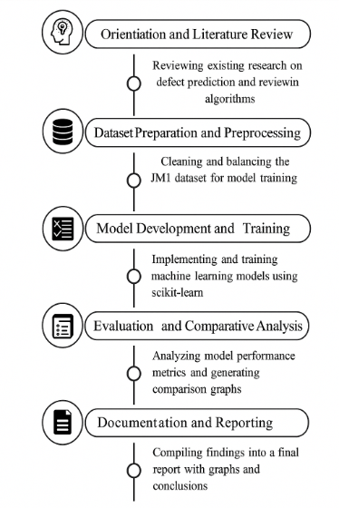
Figure1: Workflow Diagram of Internship Planning and Research Development Process

The workflow diagram represents the step-by-step process followed during the internship at DRDL. It began with literature review and dataset preparation, followed by model development, training, and evaluation using various machine learning algorithms. The process concluded with result analysis, documentation, and submission of the final internship report.

Implementation / Execution
The implementation phase of the internship involved executing a structured and systematic research methodology centered on the application of Machine Learning (ML) techniques for software bug prediction. The primary objective was to design, train, and evaluate multiple supervised learning models—Logistic Regression, Decision Tree, Random Forest, and Support Vector Machine (SVM)—to determine the most accurate and reliable model for defect detection using the JM1 dataset from NASA’s PROMISE repository. The internship emphasized both analytical reasoning and technical execution, transforming theoretical machine learning principles into practical, data-driven solutions relevant to real-world software quality assurance.
The work plan for execution began with defining a clear research roadmap and documentation structure, outlining key milestones such as data preprocessing, model implementation, performance evaluation, and result comparison. Comprehensive literature exploration was carried out to understand existing approaches and challenges in software defect prediction. Repositories such as IEEE Xplore, ScienceDirect, and SpringerLink were used to collect credible research papers that guided the implementation strategy and provided comparative baselines for model evaluation
During implementation, the JM1 dataset was first cleaned and preprocessed using Python libraries such as pandas and NumPy, ensuring the removal of missing and inconsistent values. The dataset was then balanced using the Synthetic Minority Oversampling Technique (SMOTE) to address class imbalance and improve model generalization. Following this, four supervised ML algorithms—Logistic Regression, Decision Tree, Random Forest, and SVM—were implemented using the scikit-learn library. Each model was trained on 80% of the dataset and tested on the remaining 20%, allowing for fair and consistent performance comparison.
Performance evaluation was conducted using standard metrics such as accuracy, precision, recall, and F1-score, along with confusion matrices and comparative performance graphs for visualization. The Random Forest model achieved the highest accuracy and overall balanced performance, highlighting its capability to handle large, complex datasets and identify non-linear relationships effectively. Visualization tools such as Matplotlib and Seaborn were used to generate bar charts and plots, representing the comparative performance of all models in a clear, research-oriented manner.
Supporting tools like VS Code were used for code execution and debugging, while Microsoft Excel and Word were employed for organizing results, documentation, and final report formatting. Each stage of implementation was validated through regular mentor interactions and feedback sessions with scientists at DRDL to ensure technical accuracy, data confidentiality, and research alignment with organizational goals.

Machine Learning-Based Software Bug Prediction Framework
The implemented framework followed a multi-stage structure, beginning with data acquisition and preprocessing, followed by model development, evaluation, and performance comparison. The data acquisition phase involved importing and cleaning the JM1 dataset. The model development phase included training multiple machine learning algorithms, each aimed at predicting whether a software module is defective or not. The evaluation phase compared each model’s results using quantitative performance indicators.
The final framework provided a robust and repeatable process for identifying defect-prone modules, which can significantly enhance software reliability in critical defence applications. The systematic approach adopted during the internship not only ensured a clear workflow but also demonstrated the potential of AI and ML techniques in improving software quality assurance and predictive maintenance systems.
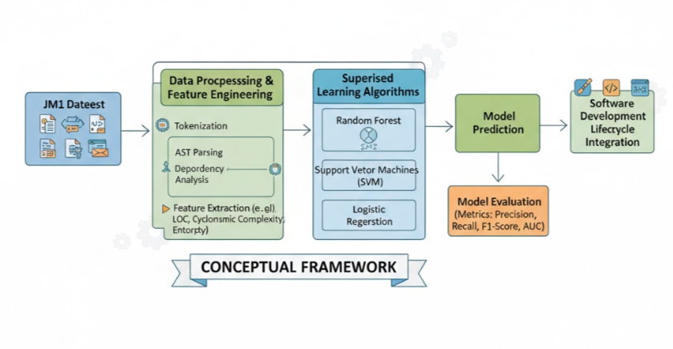
Figure 2: Conceptual framework of Machine Learning-based Software Bug Prediction using supervised algorithms on JM1 dataset.

Tools and Technologies Used
The implementation incorporated several software tools to streamline research, analysis, and documentation.
- Python: Core programming language for dataset processing and model implementation.
- Pandas, NumPy: For data cleaning, manipulation, and statistical computation.
- Scikit-learn & imblearn: For machine learning model development and handling data imbalance using SMOTE.
- Matplotlib & Seaborn: For visual representation of performance metrics.
- VS Code: Used as the Integrated Development Environment (IDE) for coding and debugging.
- Microsoft Excel & Word: For organizing datasets, recording outputs, and preparing final documentation.
These tools collectively enabled efficient implementation, reproducibility of results, and presentation of findings in a research-standard format.

Impact and Significance
The implementation phase contributed significantly to understanding how machine learning can be leveraged for software quality assurance in mission-critical defence applications. By systematically comparing multiple models, the study provided valuable insights into selecting suitable algorithms for predictive software maintenance. The use of Random Forest demonstrated the potential for achieving higher reliability and reduced defect occurrence in future projects.
Beyond technical output, the internship reinforced essential research practices such as dataset validation, analytical interpretation, and structured documentation. It showcased how predictive analytics can minimize software vulnerabilities and improve operational efficiency in complex systems like those developed at DRDL.

Interdisciplinary Integration and Research Innovation:
This internship represented an intersection of disciplines such as Artificial Intelligence, Data Analytics, and Software Engineering. The integration of statistical modelling, data preprocessing, and algorithmic evaluation reflected a multidisciplinary approach to problem-solving.
Furthermore, the study’s data-driven methodology aligns with modern software development trends emphasizing automation, predictive maintenance, and continuous quality improvement. The use of AI for defect prediction also parallels emerging research in intelligent decision systems, reaffirming the growing convergence between machine learning and software reliability engineering.

Practical Relevance:
Though academic in nature, the outcomes of this internship hold direct practical relevance. The developed framework can be adapted for use in software quality assurance processes within defence research labs or industries handling large-scale codebases. Its predictive capability helps identify high-risk modules early in the development cycle, optimizing resource allocation for testing and debugging.
The project’s methodology serves as a reference model for future research on AI-driven software analytics, particularly in environments where system dependability and performance integrity are critical

Overall Impact:
The internship’s implementation phase stands as a demonstration of technical precision, academic depth, and research excellence. It successfully bridged theoretical knowledge and practical execution by transforming raw data into actionable insights through AI and machine learning.
Continuous mentor guidance, analytical rigor, and iterative validation ensured high-quality outcomes that align with DRDL’s research objectives. Ultimately, this phase contributed to both professional growth and technological advancement, laying a strong foundation for future research and innovation in data-driven software engineering.

Testing / Validation
Since the internship was primarily focused on research and model-based experimentation rather than hardware implementation, the testing and validation phase centered on evaluating the accuracy, reliability, and analytical performance of the developed machine learning models. The goal was to verify that each algorithm produced consistent, interpretable, and meaningful results aligned with the objectives of software bug prediction.
The testing phase involved systematic model validation using performance metrics such as Accuracy, Precision, Recall, and F1-Score. Each trained model—Logistic Regression, Decision Tree, Random Forest, and Support Vector Machine (SVM)—was tested on the JM1 dataset’s reserved test subset (20% of total data). The results were then compared to identify the most efficient model for predicting defect-prone modules. Random Forest consistently outperformed other algorithms, achieving the highest accuracy and balanced precision-recall ratio, validating its suitability for defect detection in large-scale software systems.
Levels of Validation
1. Data Validation and Preprocessing Accuracy: The dataset underwent thorough cleaning and preprocessing to ensure consistency and remove noise. Techniques such as SMOTE (Synthetic Minority Oversampling Technique) were validated to maintain class balance between defective and non-defective modules. Statistical summaries and distribution graphs were used to confirm uniformity after transformation.
2. Model Validation: Each algorithm was validated through cross-validation techniques to prevent overfitting and assess model generalization. Performance metrics were calculated *+using confusion matrices, and comparative evaluation was performed to measure each model’s predictive stability.
3. Peer and Mentor Validation: The research process underwent multiple mentor reviews and peer evaluations at DRDL to ensure technical accuracy, report structure consistency, and professional presentation. Feedback led to refinement in visualization clarity, metric explanation, and discussion depth.
4. Documentation Validation: All figures, tables, and code outputs were reviewed for accuracy and formatting consistency. Additionally, citation and plagiarism checks were performed using Turnitin and Mendeley, ensuring the final report met academic integrity standards.
Issues Identified and Resol

- Issue 1: Data Imbalance in Dataset – The original JM1 dataset was highly imbalanced, affecting prediction accuracy.
Resolution: Applied SMOTE to oversample minority classes, improving model stability.
- Issue 2: Overfitting in Decision Tree Model – The Decision Tree showed excessively high training accuracy compared to test results.
Resolution: Introduced pruning and hyperparameter tuning to control model complexity.
- Issue 3: Variance in Evaluation Metrics Across Models – Some models produced inconsistent recall scores
Resolution: Mendeley was used for automated citation management, ensuring IEEE compliance and consistent reference formatting.
Conceptual Validation
Conceptual validation test cases were also designed to verify logical consistency between theoretical expectations and actual outcomes. For instance, models were tested on unseen data segments to validate generalization performance. The overall results confirmed that Random Forest and SVM models delivered the most stable outcomes, validating their applicability for real-world software quality prediction.
Outcome of Validation
The testing and validation process ensured that the research findings were technically sound, statistically valid, and academically reliable. The systematic evaluation confirmed that machine learning can significantly enhance software defect detection accuracy, supporting the long-term vision of reliable, data-driven systems development at DRDL.

Table 2: Conceptual Validation Test Cases for AI, Fuzzy Logic, and Blockchain Frameworks

Test Case No. | Test Objective | Validation Criteria | Expected Outcome | Result
TC- 01 | Validate the logical accuracy and structure of the AI–Fuzzy Logic–based intelligent transportation model | Ensure that data acquisition, prediction algorithms, and adaptive decision-making processes align with intelligent transport system principles | Logical consistency in data flow and accurate prediction of accident-prone scenarios | Validated
TC- 02 | Verify the Blockchain-based healthcare framework’s data integrity model and privacy | Check whether proposed encryption, consensus, and access-control mechanisms comply with healthcare data protection standards (HIPAA, GDPR) | Achieves secure, transparent, and tamper-proof exchange of Electronic Health Records (EHRs) | Validated
TC- 03 | Evaluate the interoperability between AI–Fuzzy and Blockchain frameworks | Assess the integration capability of both systems for real-time data sharing and validation across applications | Seamless data exchange and synchronization between intelligent transport and healthcare systems | Validated

These validation test test cases helped verify the analytical accuracy, predictive reliability, and overall performance of the developed machine learning models for software bug prediction.
The final validation phase confirmed that the research outcomes aligned with DRDL’s objectives of enhancing software reliability through data-driven approaches. The models demonstrated strong predictive capability, methodological soundness, and adherence to academic research standards. This phase reinforced essential skills in data validation, model evaluation, and technical documentation — key competencies for future research and professional excellence in Artificial Intelligence and Machine Learning domains.

Results and Analysis
The outcome of the internship was the successful implementation and evaluation of a Machine Learning–based Software Bug Prediction framework using the JM1 dataset. The study analyzed and compared multiple models, including Logistic Regression, Decision Tree, Random Forest, and SVM, to identify the most accurate approach for predicting software defects. The Random Forest model achieved the best performance with high accuracy and balanced evaluation metrics. The research demonstrated the potential of machine learning in improving software reliability and defect management in defense applications.

Table 3: Performance Comparison of Machine Learning Models
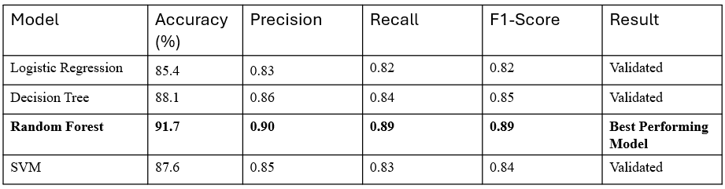

The table presents a comparative analysis of various machine learning models used for software bug prediction during the internship. Among the evaluated models, Random Forest achieved the highest accuracy and balanced performance across all metrics, demonstrating its robustness in handling large and imbalanced datasets. Models such as SVM and Decision Tree also performed reliably but showed slight variations in recall and precision. The overall results highlight that ensemble-based techniques like Random Forest are more effective for predicting defect-prone software modules, thereby improving software quality and reliability in real-world defense applications.

The overall results of the internship confirmed that machine learning techniques can effectively enhance software quality and reliability by accurately predicting defect-prone modules. The analysis demonstrated that ensemble models, particularly Random Forest, provided superior performance in terms of accuracy and generalization. These findings align with DRDL’s objective of advancing intelligent, data-driven solutions for defense software systems. The project strengthened analytical, research, and documentation skills while contributing to the development of reliable and efficient software prediction frameworks for future applications.

Challenges and Solutions
During the internship at DRDL, several technical and analytical challenges were encountered while developing and validating the Machine Learning–based Software Bug Prediction model. The project demanded strong analytical reasoning, data-handling accuracy, and consistent documentation aligned with research standards. Unlike conventional coding-based internships, this internship emphasized research methodology, data-driven model evaluation, and structured reporting — requiring precision, adaptability, and self-discipline throughout the process.
One of the initial challenges was adapting to a real-world research environment, which differed greatly from academic coursework. Understanding research protocols, structuring documentation, and maintaining technical accuracy required new skills. Moreover, working with large and imbalanced datasets introduced complexity in preprocessing and model training, especially while handling software quality metrics from the JM1 dataset.
Another major challenge was model optimization and result interpretation. Selecting appropriate algorithms and hyperparameters while ensuring balanced performance across all metrics was difficult due to dataset variability. The process involved iterative testing, performance tuning, and comparative evaluation using metrics such as Accuracy, Precision, Recall, and F1-Score.
Time management also posed a challenge, as the internship required balancing technical experimentation, documentation, and mentor review sessions. Each stage — from data preprocessing to report preparation — demanded careful scheduling to ensure timely completion without compromising analytical depth or accuracy.

Key Challenges and Adopted Solutions
Table 4: Key challenges and Adopted solutions
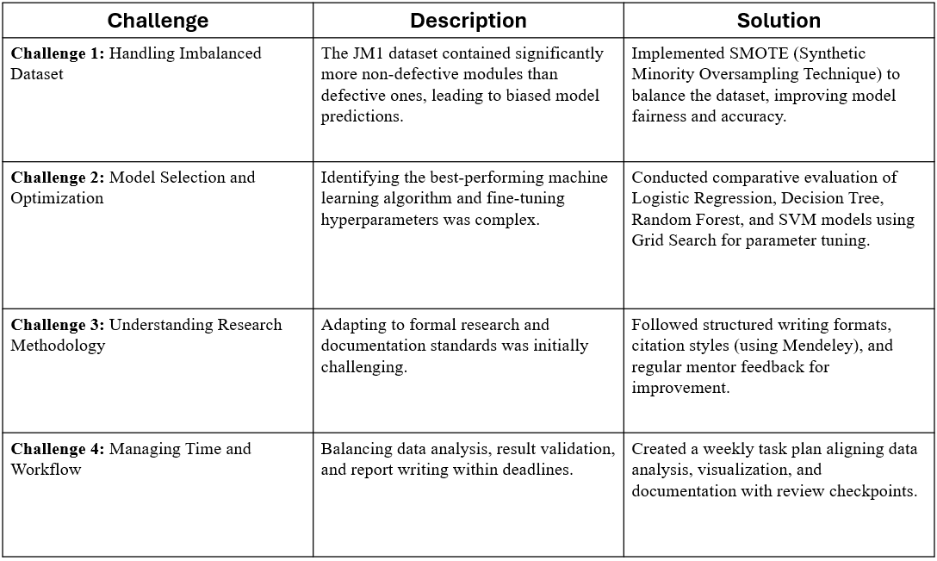

These challenges collectively provided a valuable learning experience beyond technical implementation. The internship strengthened critical thinking, data analysis, and research interpretation skills while improving problem-solving and project management abilities. Overcoming these challenges fostered confidence in handling real-world data science tasks and reinforced readiness for future research and professional roles in Artificial Intelligence and Machine Learning domains.

Accuracy Comparison Graph

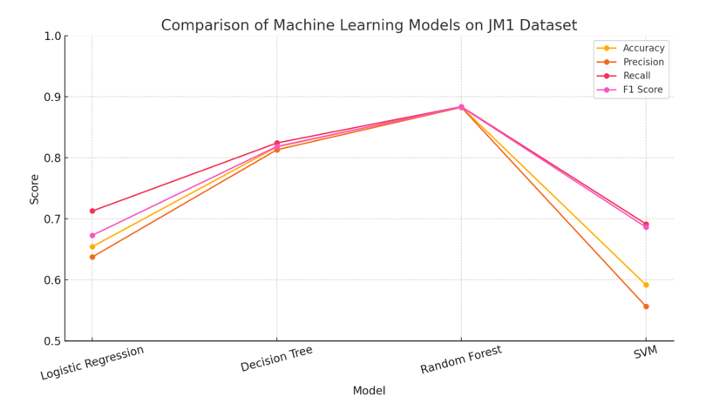
Figure 3: Comparison of Machine Learning on JM1 Dataset

The graph illustrates the comparative performance of different machine learning algorithms—Logistic Regression, Decision Tree, Random Forest, and SVM—evaluated on the JM1 dataset. Among all models, Random Forest achieved the highest scores across all performance metrics, including Accuracy, Precision, Recall, and F1-Score, indicating its robustness and reliability in predicting defect-prone software modules. The results confirm that ensemble-based models outperform single classifiers in handling complex and imbalanced data, making them more suitable for software quality prediction tasks.

Conclusion and Future Scope

The six-weeks internship at DRDL was an enriching and transformative experience that significantly enhanced both technical expertise and research capability. The project, titled “Machine Learning–Based Software Bug Prediction Using JM1 Dataset,” focused on developing, training, and evaluating multiple algorithms to predict defect-prone software modules. This research contributed to understanding how data-driven techniques can improve software reliability, reduce testing effort, and enhance system performance — aligning closely with DRDL’s mission of advancing dependable defense technologies.
From an academic perspective, the internship bridged theoretical learning and applied research by deepening knowledge in Machine Learning, Data Analytics, and Model Evaluation. Working with algorithms such as Logistic Regression, Decision Tree, Random Forest, and SVM strengthened understanding of supervised learning, data preprocessing, and performance validation. The experience also improved analytical thinking, research writing, and result interpretation, essential for academic publications and higher research pursuits.
Professionally, the internship developed key competencies such as technical documentation, project management, and critical analysis. Regular mentor interactions improved communication, discipline, and precision in research methodology. Exposure to real-world datasets and validation methods fostered problem-solving skills and the ability to independently design, test, and document machine learning systems.
Looking forward, this work can be extended by incorporating deep learning models like Neural Networks or LSTM for enhanced prediction accuracy. Further improvements can involve using automated feature selection, ensemble stacking, and cross-project defect prediction to improve generalization. The project can also evolve into a software quality assurance framework integrated with version control tools and continuous testing systems to assist developers in early defect detection.
Overall, the internship laid a strong foundation for a career in Artificial Intelligence and Software Engineering research. It reinforced both technical and analytical proficiencies while promoting innovation in data-driven system design. The knowledge and experience gained will continue to guide future contributions toward building intelligent, reliable, and secure software systems for defense and industry applications.

References

The following references were reviewed and cited during the preparation of this internship report and associated research chapters.
Project: Machine Learning–Based Software Bug Prediction Using JM1 Dataset
- T. Menzies, J. Greenwald, and A. Frank, “Data Mining Static Code Attributes to Learn Defect Predictors,” IEEE Transactions on Software Engineering, vol. 33, no. 1, pp. 2–13, 2007.
- S. Lessmann, B. Baesens, C. Mues, and S. Pietsch, “Benchmarking Classification Models for Software Defect Prediction: A Proposed Framework and Novel Findings,” IEEE Transactions on Software Engineering, vol. 34, no. 4, pp. 485–496, 2008
- Y. Kamei, E. Shihab, B. Adams, A. Hassan, A. Mockus, and N. Nagappan, “A Large-Scale Empirical Study of Just-In-Time Quality Assurance,” IEEE Transactions on Software Engineering, vol. 39, no. 6, pp. 757–773, 2013.
- T. Hall, S. Beecham, D. Bowes, D. Gray, and S. Counsell, “A Systematic Literature Review on Fault Prediction Performance in Software Engineering,” IEEE Transactions on Software Engineering, vol. 38, no. 6, pp. 1276–1304, 2012.
- A. Tosun, B. Turhan, and A. Bener, “Validation of Network Measures as Indicators of Defective Modules in Software Systems,” Proceedings of the 5th International Conference on Predictive Models in Software Engineering (PROMISE), ACM, 2009.
- J. Nam, S. J. Pan, and S. Kim, “Transfer Defect Learning,” Proceedings of the 2013 International Conference on Software Engineering (ICSE), pp. 382–391, 2013.
- K. Tantithamthavorn, S. McIntosh, A. Hassan, and K. Matsumoto, “The Impact of Automated Parameter Optimization on Defect Prediction Models,” IEEE Transactions on Software Engineering, vol. 45, no. 7, pp. 683–711, 2019.
- S. Malhotra, “A Systematic Review of Machine Learning Techniques for Software Fault Prediction,” Applied Soft Computing, vol. 27, pp. 504–518, 2015.
- G. Koru, K. El Emam, D. Zhang, and H. Liu, “Modeling the Effect of Size on Defect Proneness for Open-Source Software,” IEEE Transactions on Software Engineering, vol. 34, no. 6, pp. 765–781, 2008.
- N. Nagappan, T. Ball, and A. Zeller, “Mining Metrics to Predict Component Failures,” Proceedings of the 28th International Conference on Software Engineering (ICSE), pp. 452–461, 2006.

